HEY NEIGHBOR!

My name is ___________________________________
and I live in your neighborhood at ________________________________________.
June 5th- 7th, I am taking part in LOVE VC, a weekend of virtual volunteering, hosted by local nonprofit, ACTION VC. I am participating in a card project for the high school graduates living in our very own neighborhood and I would love your help! We love our seniors and want them to know how proud we are of them. Although circumstances may be a lot different than we expected, let's join together in celebrating the class of 2020!
Please join me in making a few cards of encouragement, advice and celebration to pass along to each of the graduating seniors in our neighborhood. Here’s how:

ACTION VC GUIDELINES FOR PROJECT GRAD LOVE:

- The more cards you can make the better! We want to make sure every graduate gets at least a 5 card bundle. Get your family involved and make even more!
- Cards must be legible and handwritten.
- Take the time to impart some wisdom, encouragement, and celebration to the grads, who are embarking on an uncertain future in an uncertain time! Give them a piece of advice, let them know we are proud of them, and let them know their community loves them! Not sure what to say? Check out the Project Grad Love Card Template on www.ACTIONvc.org/resources.
- Keep it Generic. Your card may be going to your next-door neighbor, or it may be going to a neighbor a block away- please keep your card applicable to all.
- Envelope your cards if you can! It’s so much nicer to open up an enveloped card, don’t you think? Leave your enveloped cards unsealed and unstamped and put them in a larger envelope or box.
- Share your act of kindness! We love seeing photos of your volunteering, and it helps promote our work more than you know. If you tag us @action_vc and use #lovevc2020, your photo will be entered in a drawing to win a $30 amazon gift card!

Please drop off all letters to my home (at the address above) at the latest by June 10th, so I can deliver the letters by Graduation Day, June 12th!

Thank you for joining me!

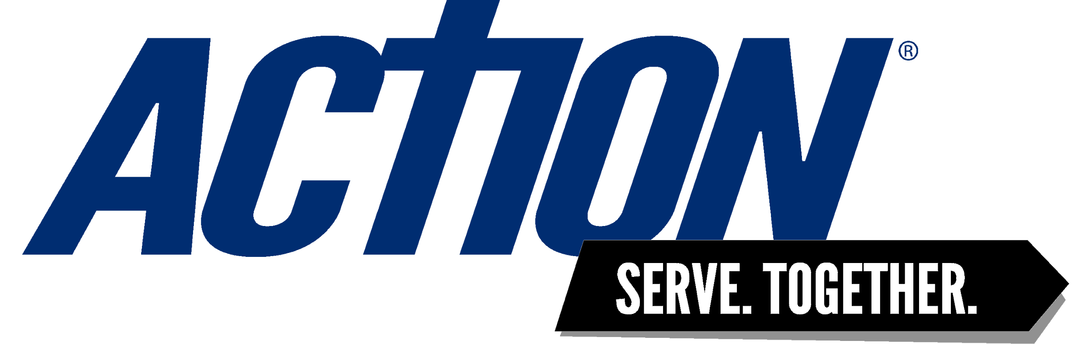
HEY NEIGHBOR!

My name is ___________________________________
and I live in your neighborhood at ________________________________________.
June 5th- 7th, I am taking part in LOVE VC, a weekend of virtual volunteering, hosted by local nonprofit, ACTION VC. I am participating in a card project for the high school graduates living in our very own neighborhood and I would love your help! Graduating seniors are missing out on the usual fanfare of their graduation- so wouldn’t it be great if our neighborhoods could rally around them instead?
Please join me in making 2-3 handwritten cards of encouragement, advice and celebration to pass along to each of the graduating seniors in our neighborhood. Just keep them generic, since they could be going to your neighbor next door or down the street. Not sure what to say? Check out the Project Grad Love Card Template on www.ACTIONvc.org/resources. When you are finished, put each card you make in an unsealed and unstamped envelope. It’s so much nicer to open up an enveloped card, don’t you think?
Drop off your cards at my address by June 10th, 2020 to make sure they are delivered by graduation June 12th!
Thank you for joining me!
Sincerely,
Your Neighbor

